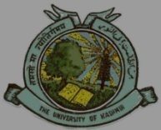
P. G. DEPARTMENT OF PSYCHOLOGY
UNIVERSITY OF KASHMIR
NAAC ACCREDITED GRADE ‘A’

NOTICE
All the students of M. A. 1st semester (batch 2016) and 2nd Semester (batch 2015) who have missed any GE/OE course/s run by the Department of Psychology are informed that their examination for the missed paper/s will be held on Saturday, 13/05/2017 at 11.30 a.m. in the department.

Sd/=
Head of the Department
No.F(Exam GE/OE-PG class)KU/17
Dated:- 11-05-2017

